**FINANCIAL FORESTING**

1.Recursive Algorithms

Recursion is a method where a function calls itself to solve smaller instances of the same problem. It simplifies problems like calculating future values by breaking them into smaller sub problems like traversal tree, factorial.

FinancialForest.java

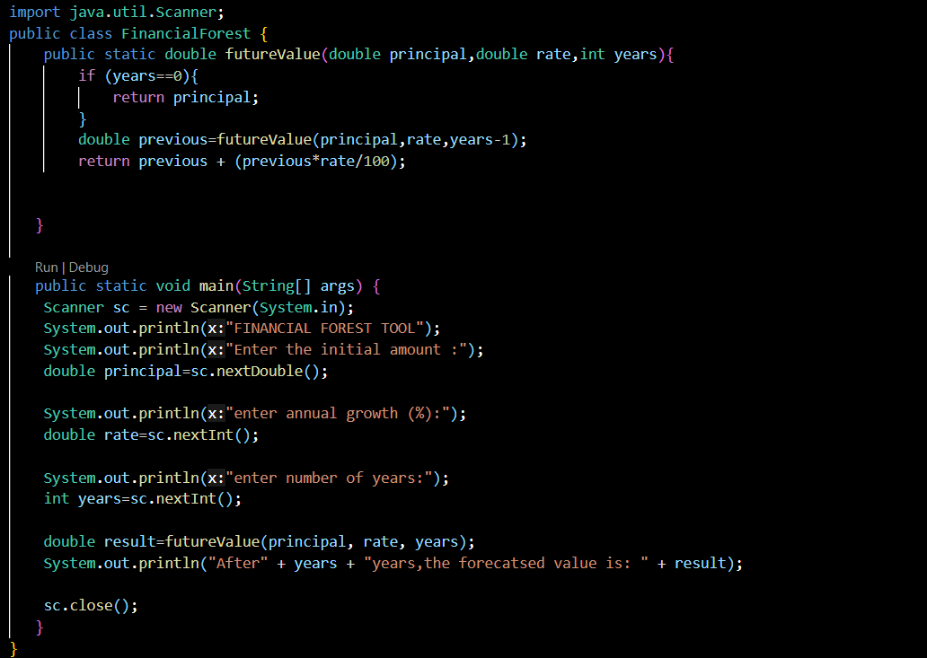

**OUTPUT**

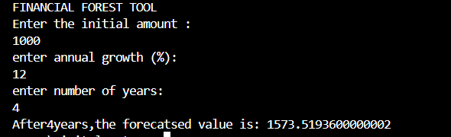

4.Analysis

The Time complexity of the program is O(n) where n is years. Each recursive call does a constant amount of work.

To optimize the recursion solution,

We can use iterative Approach where we can use a loop instead of recur sion to avoid overhead from function calls and stack usage.

Or we can use memorization where there is no repeated subproblem computation, each year depends on exactly one previous year’s result